Name _______________________________________________ Hour _________________ Due __________

Aristotle Worksheet
Learning Target: St 5 Obj 1d Demonstrate that there are many ways to classify things.

Read this:
Years ago people realized that there are many different types of living organisms. There were animals and there were plants. Some had claws, some had sharp teeth, some feathers and beaks. Plants had a wide range of different types: shape, color, size, edible (meaning you could eat it), or poisonous. As people looked at these organisms they tried to organize them into an order (groups or categories). They were trying to classify these organisms. Classification is the grouping of things according to similar characteristics.

Question:
What are some things that you have put in order or into groups?
Item How you organized or classified it

Examples: CD’s Alphabetically
Books By size, largest to smallest

1.

2.
Read this:
Aristotle was a Greek philosopher that observed nature. He came up with his own system of classification of living organisms. First, he divided organisms into two groups: PLANTS and ANIMALS. He then placed animals into three groups according to the way they MOVED. One group included all animals that flew, another group included all animals that swam, and the third group included all animals that walked. The last group included all plants.

Directions:
Place the following organisms into four groups using Aristotle’s way of classification. Next to each organism, write which group(s) the organism belongs to.
Hint: What were the four groups that Aristotle used?

Hammerhead shark   | Chipmunk  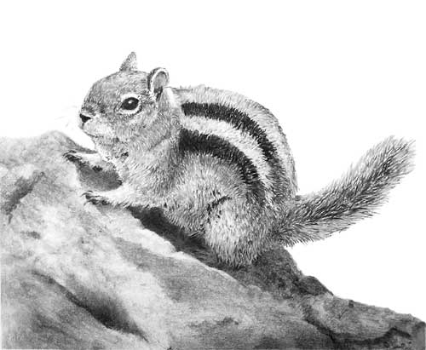 | Polar Bear  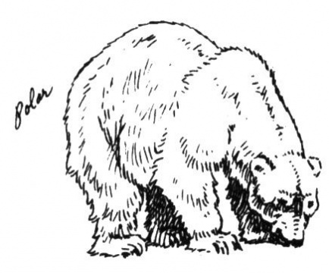 | Panther  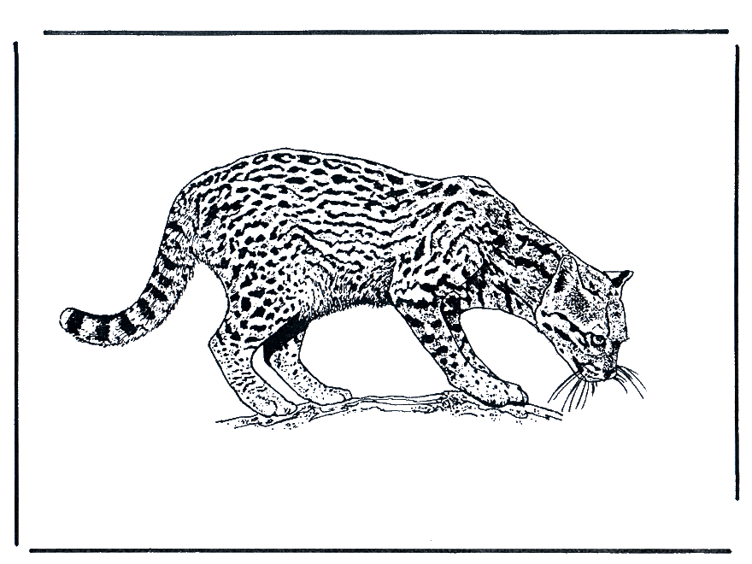 | Golden Eagle  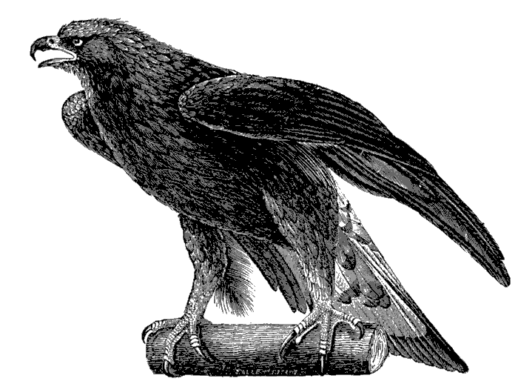
Gray wolf  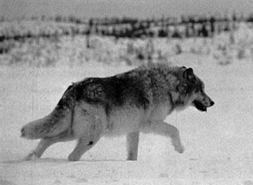 | Lion  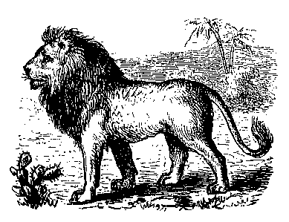 | House cat   | Chameleon  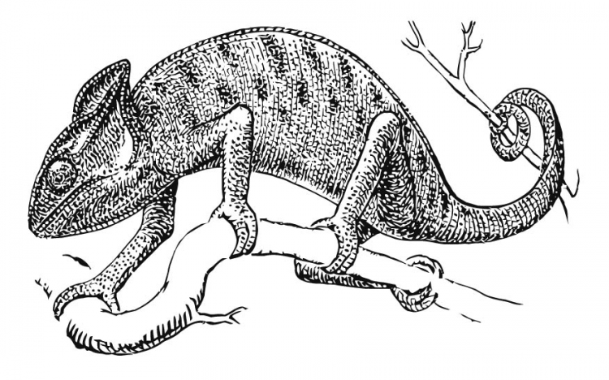 | Fruit bat  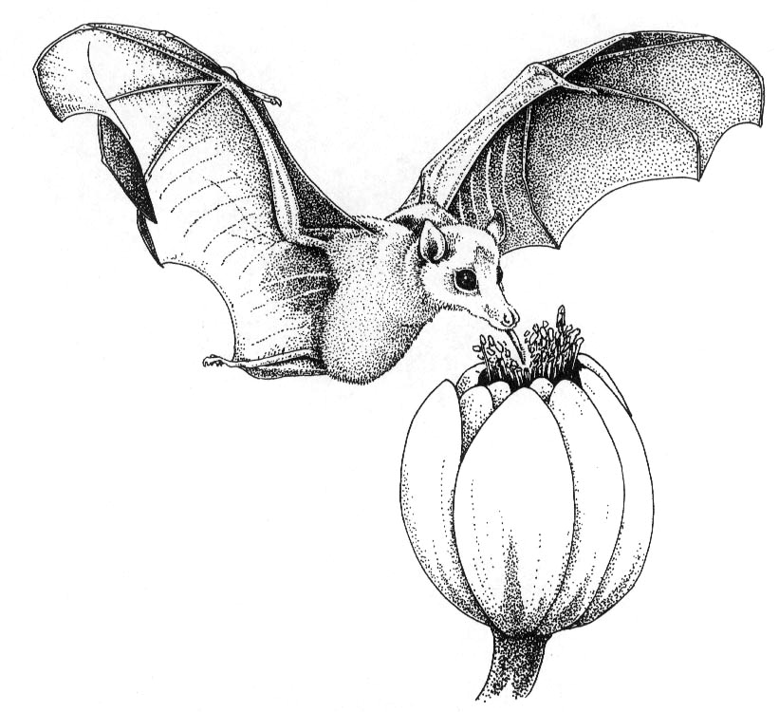
Penguin  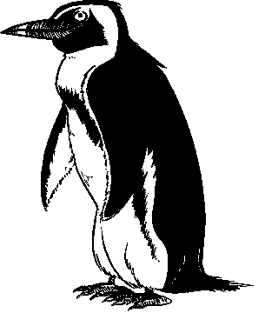 | Bluebird  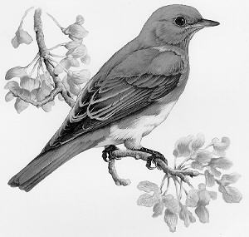 | Angel fish  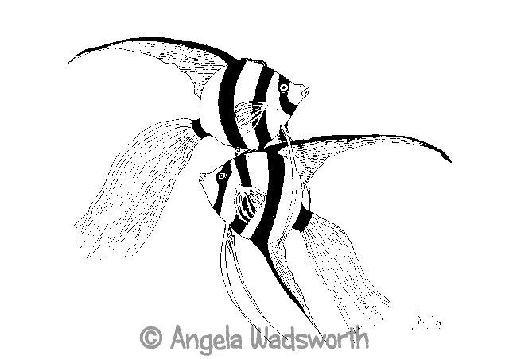 | Bumble bee  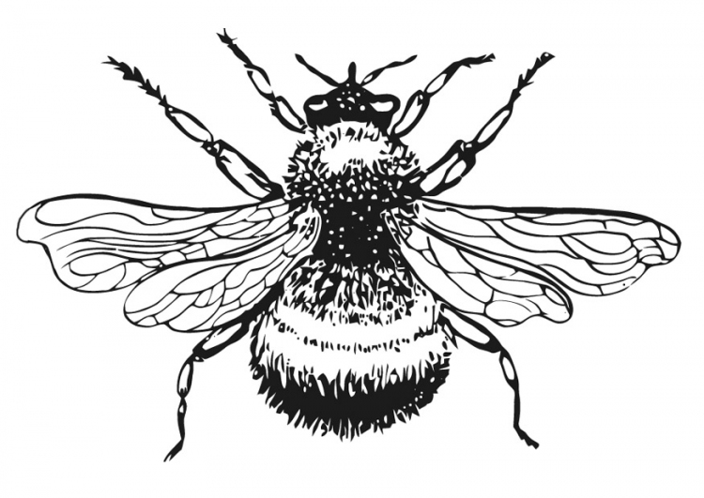 | Daisy  
Garter snake  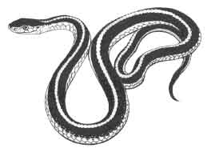 | Starfish  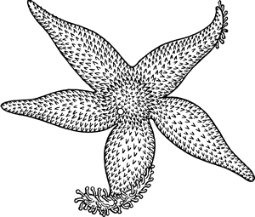 | Rainbow trout  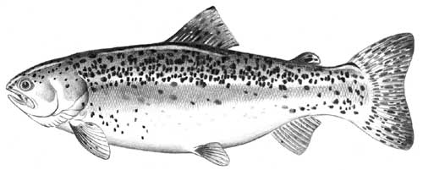 | Aspen tree  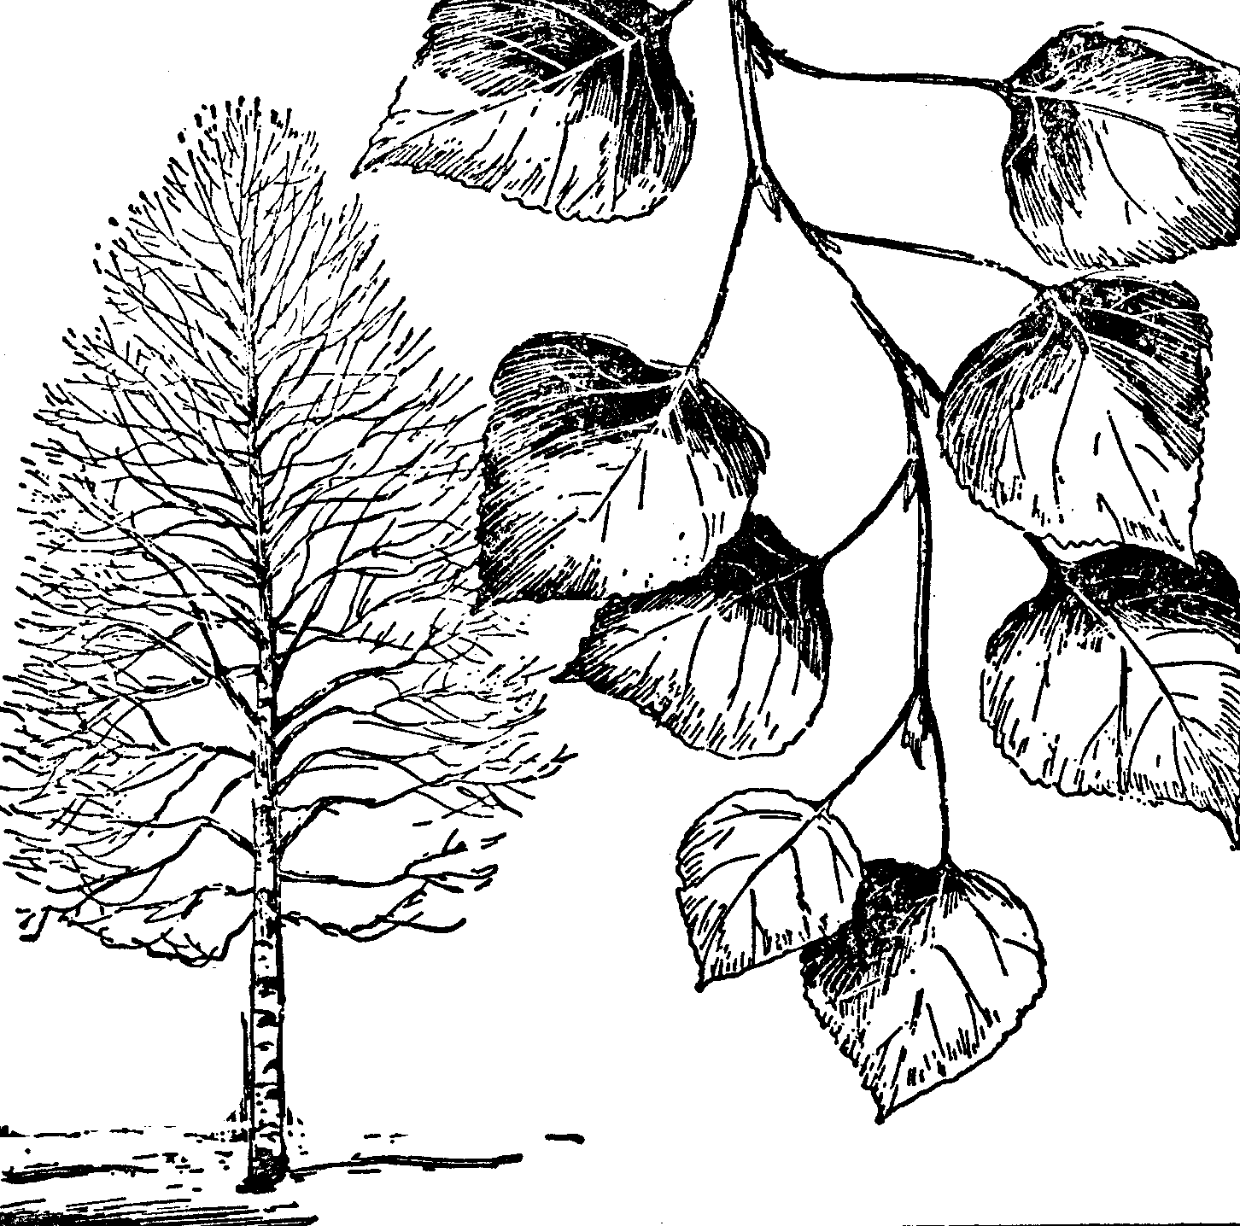 | Porpoise  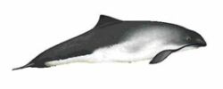
Crayfish  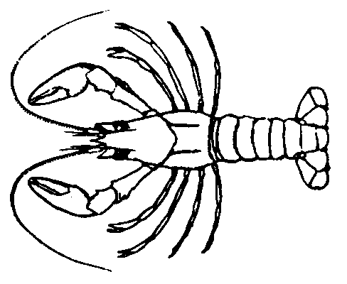 | Tree frog  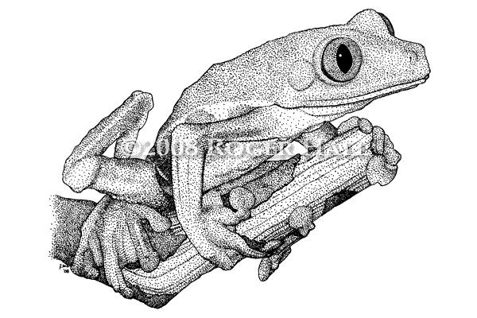 | Ponderosa pine  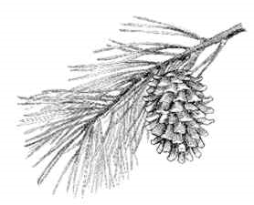 | Flying squirrel  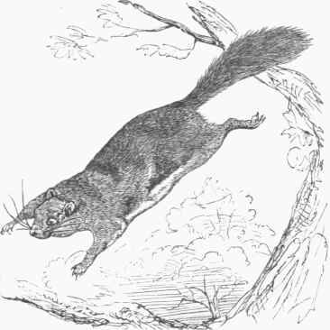 | Sting ray  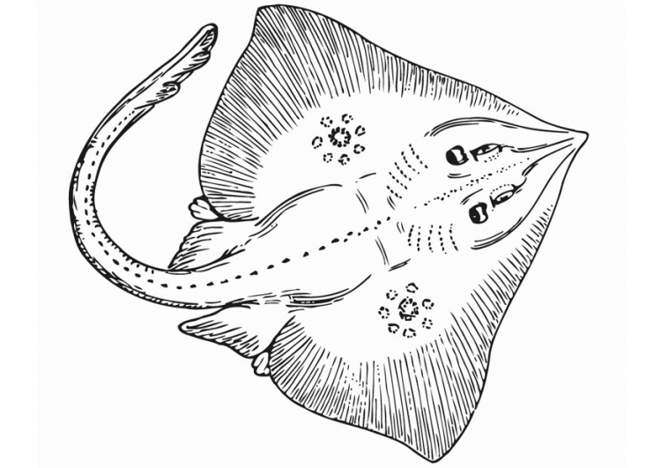
Duck   | Lady bug  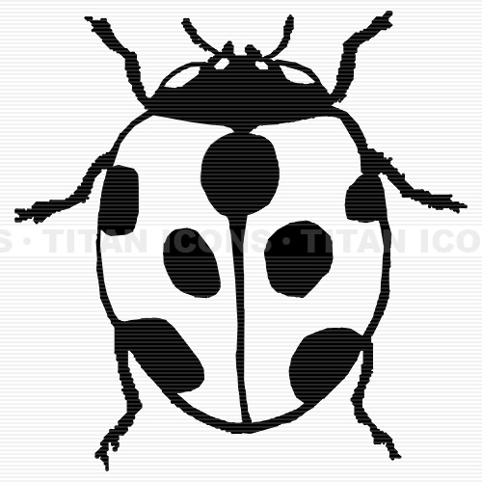 | Ostrich  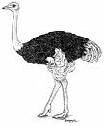 | Praying mantis  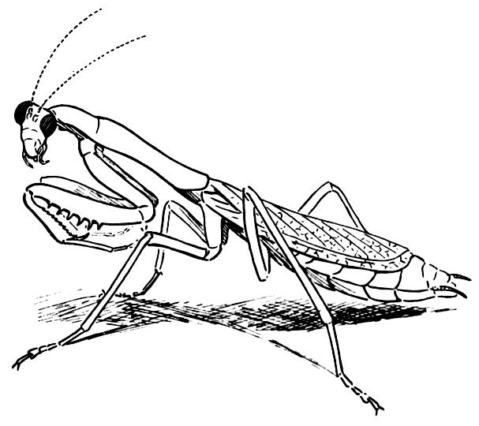 | Skink  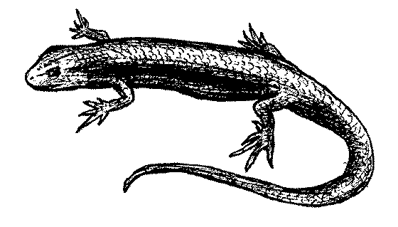

Next:
Separate each of the living things from the previous page into Aristotle’s groups.

Plants:

Animals that swim:

Animals that fly:

Animals that walk:

Questions:
- What are some problems with using Aristotle’s way of classification?

- What would be a better way of classification?

- How would YOU classify these living organisms?

