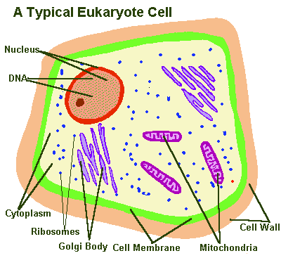
Eukaryotic Cells
Name: _____________________ Date: _______ Hour:__
Review:
1. Read pages 66 -67 of your green text book. Create a Eukaryotic and Prokaryotic double bubble map in the space below. Provide at least two similarities and four differences between the Eukaryotic and Prokaryotic cell types below.

Book Reading/Tree Map Assignment: Carefully read pages 68 – 75 of the green text book. While reading the pages please stay focused on learning what exactly each cell organelle does for the cell. Complete the Tree Thinking Map that is started for you on the back of this page. Get the needed information for each cell organelle from reading the book pages.
Your completed thinking map should include the following.
Thinking Map Rubric:
1. The name of each Eukaryotic cell organelle. (cell membrane, cell wall, nucleus, ribosomes, endoplasmic reticulum, mitochondria, chloroplasts, golgi complex (body), vacuoles, lysosomes)
/10
2. Rough sketch or picture next to each organelle. /10
3. Two of the most important known facts about each organelle listed. /10
4. Your name on this paper. /5
* Please see an example of how to do this on the back. The 1st cell organelle is done for you.
Extra Time?
1. Get one Kids Discoverer Magazine from the teacher to share with your desk partner. Take 10 Minutes to Skim and Scan the pages for old and new information on cells. Be sure to do this carefully because this background knowledge will be important for today’s activity.

