The Atomic Theory Development Notes
Scientist Name | Contribution Detail | Year
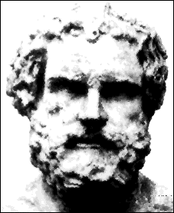  Democritus | He concluded that atoms are….  - indivisible .  - too small to see.  3. always moving.  * He named the atom after the Greek word Atoms = Indivisible | 440 BC
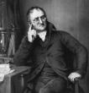  John Dalton | He created the 1st Atomic Theory.  1. All matter is made of atoms. Atoms cannot be created, divided, or destroyed.  2. Atoms of the same element are alike.  3. Atoms of different elements are different.  4. Atoms join with other atoms to molecules and compounds. | 1803
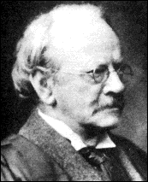  J.J Thompson | 1. He discovered the negative particles (electrons) of atoms  2. He created the plum pudding” model of the atom | 1897
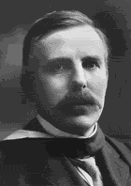  Ernest Rutherford | - He proved that there is a positive charged nucleus in the atom. | 1909
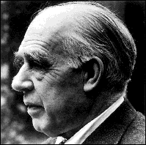  Niels Bohr | Electrons orbit the nucleus like planets around the sun | 1913

