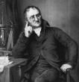**The Development of *The Atomic Theory***

**1803**

**John Dalton**

He created the 1st Atomic Theory

1. Atoms are invisible/indivisible.

2. Each Element has Unique Atoms.

3. Atoms of different elements are

dissimilar.

4. When atoms of different elements combine they form compound molecules

**440 B.C.**

**Democritus**

He named the atom

after the Greek word atomos

which = indvisible.

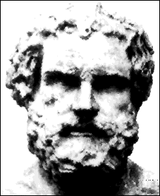

[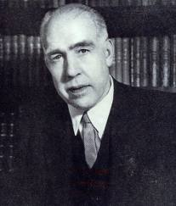](http://www.google.com/imgres?imgurl=http://3.bp.blogspot.com/-oX2fy1YxuV0/TYxE0akfbYI/AAAAAAAAB1U/9q4dIMzo_l4/s1600/Scientist%252BNiels%252BBohr.jpg&imgrefurl=http://scientistsinformation.blogspot.com/2011/03/scientist-niels-bohr-1885-1962.html&h=659&w=563&sz=117&tbnid=ZZQfE6IYJFL9zM:&tbnh=93&tbnw=79&prev=/search%3Fq%3DPicture%2Bof%2BNiels%2BBohr%2Bscientist%26tbm%3Disch%26tbo%3Du&zoom=1&q=Picture+of+Niels+Bohr+scientist&usg=__afhbnC5X55non3ROB_RaFRswr_c=&docid=SV8Cvbe_PeHAvM&sa=X&ei=VWaQUOeFFcG2igKAwIGIAw&ved=0CCQQ9QEwAQ&dur=1312)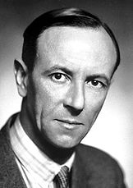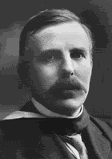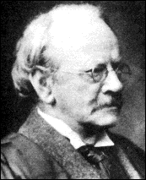

**Modern Theory Scientists**

**Erwin Schrodinger and Werner Heisenberg**

They determined that the electrons don’t orbit in clouds around the nucleus and the exact pathway or location of the electron cannot be known.

**1932**

**James Chadwick**

He discovered the Neutron.

**1913**

**Niels Bohr**

He proposed his

“Planetary Model” of the atom.

He said that the electrons orbit the

nucleus like planets around the sun.

**1903**

**Ernest Rutherford**

He performed experiments

to prove that atoms had positive

charged particles in the nucleus.

**1897**

**J.J. Thompson**

He performed experiments

with a cathode ray tube to

discover the negative particles

of the atom (electrons).