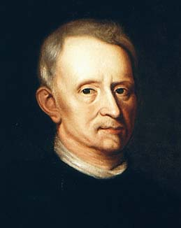**The Development of *The Cell Theory***

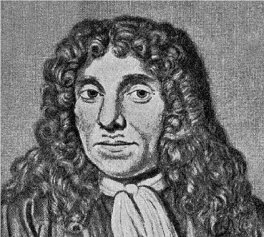

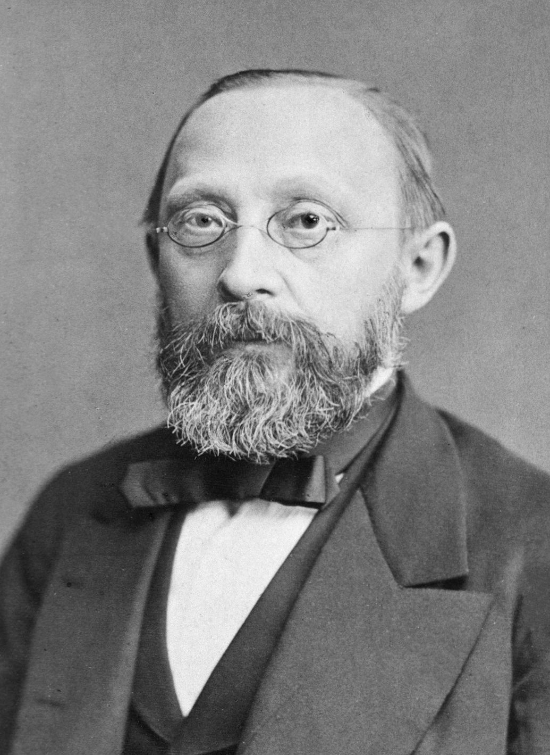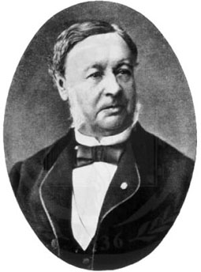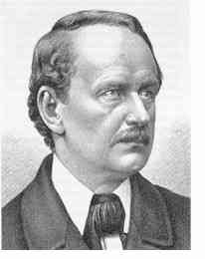

**Word Bank**

**Years Person Contribution**

1665 Rudolf Virchow Discovered bacteria

1673 Robert Hooke Discovered Cells

1838 Mathieus Schleiden Discovered Plant Cells

1839 Theodore Schwann Discovered Animal Cells

1858 Anton Van Leeuwenhoek Cells come from other exisiting celle